1. What are the various elements of the Excel interface? Describe how they're used.

* Quick Access Toolbar: It is present at the top left of the excel window. By default, it has save, undo and redo commands. This can be customised as well. User can add their mostly used commands for easy access.
* Ribbon: It has several tabs such as File, Home, Insert, Page Layout, Formulas, Data, Review, View. Help. We can also add Add ins
* Name Box: It displays the name of the active cell
* Insert Function: It is beside the Name box. It is a shortcut when user want to insert a function.
* Formula Bar: It is beside the insert function box. It lets users to enter, edit data, formula that will appear in the selected cell
* Status Bar: It is in the bottom left corner of the Excel window displays information about the current mode of the workbook
* Zoom Slider Control: Helps to zoom in and zoom out the worksheet.
* Additionally, excel worksheet has Column and Row headings, Sheet tabs as well

1. Write down the various applications of Excel in the industry.

* Managing Product Information
* Sales reporting
* Stock and Inventory Management
* Automate Business Tasks
* Used for Accounting
* Performance Reporting
* People Management

1. On the ribbon, make a new tab. Add some different groups, insert commands in the groups and name them according to their commands added. Copy and paste the screenshot of the steps you followed.

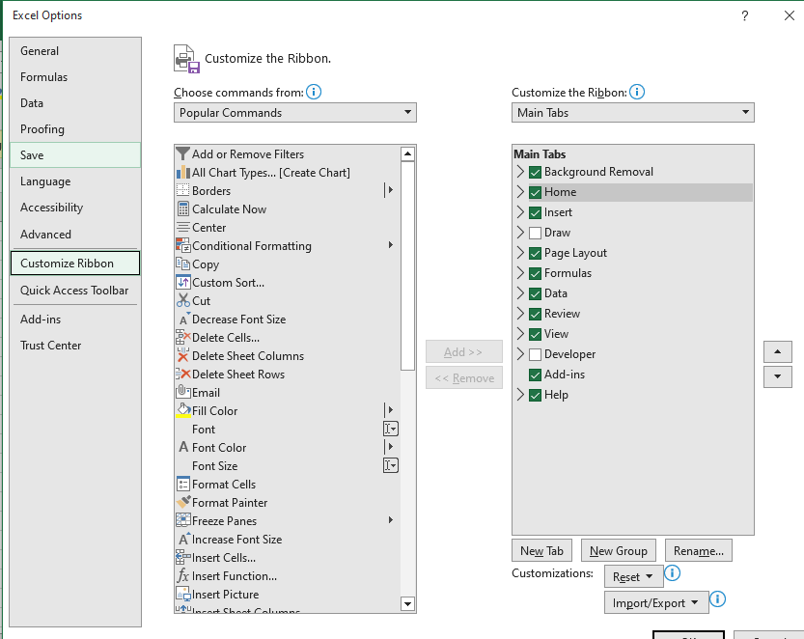

1. 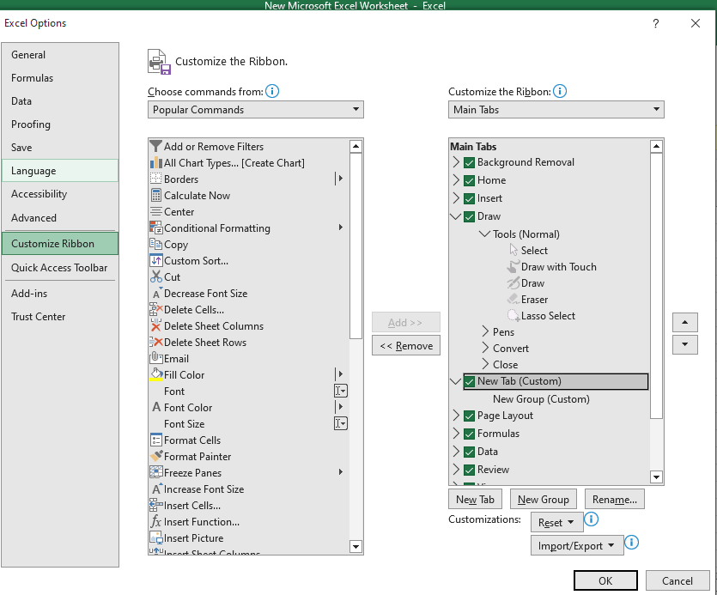
2. 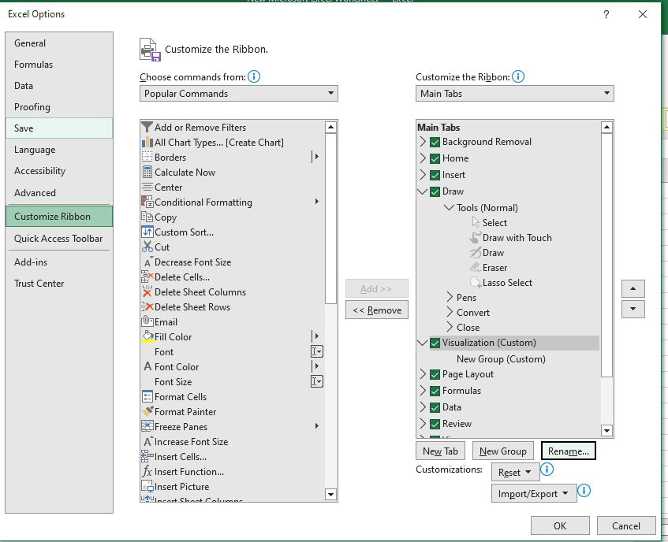

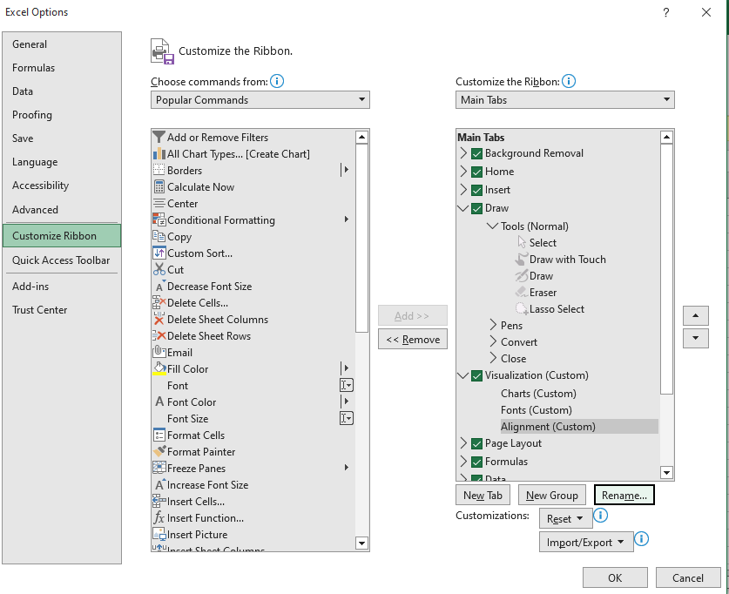

1. Make a list of different shortcut keys that are only connected to formatting with their functions.

(Can’t comprehend)

1. What distinguishes Excel from other analytical tools?

* It’s easy to get started with Excel.
* Can do a lot of things with Excel: modeling, visualization, reports, dynamic charts, etc.
* It can help to understand the meaning of many operations before further learning other tools (such as Python and R)

1. Create a table and add a custom header and footer to your table.

